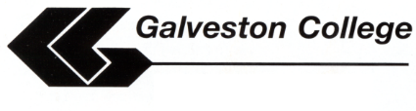

CLASSROOM RECORDING DEVICE AGREEMENT

NAME: SEM/YEAR:

STUDENT ID# PHONE #

Galveston College agrees to provide the following services:
  - Evaluation for eligibility to use recording devices in the classroom.
  - Provision of recording devices (when available) throughout the period of continuous enrollment at Galveston College.

By signing this agreement, I agree to the following conditions:

☐ I must be registered with Galveston College Special Services Office and qualify to use recording devices in the classroom.

☐ I must provide appropriate documentation that demonstrates my need for recording devices.

☐ I must show evidence that I am registered at Galveston College for the current semester and particular course(s) for which I am requesting recording devices.

☐ I will not revise, convert, disassemble, modify, sell, license, rent, loan or otherwise distribute recorded materials to any other person, institution or agency and will not allow anyone else to do so.

☐ I agree that I will pick up the recording device within 2 weeks of the request.

☐ I will immediately notify Galveston College Special Services about any class or schedule changes.

☐ I agree that any violation of this agreement may result in penalties including service suspension until I meet with the Special Services Advisor. Repeated offenses may result in suspension of services until arrangements can be made for compliance.

Galveston College Special Services Office and agree to the above conditions.
(please print name)

STUDENT SIGNATURE: DATE:

GC REPRESENTATIVE’S SIGNATURE: DATE:

